2020 TROJAN INVITATIONAL

Pleasantville AD: Joel Allman
Contact: (515) 848-0529 or Cell# (319) 560-2018

Thank you for your participation in the 2020 Pleasantville Trojans Cross Country Invitational to be held at The Pleasantville Golf and Country Club on Monday, September 14th. We are running Junior High, JV/Varsity races.

Schedule of the races is as follows:

Jr. High boys and girls (Combined) 4:30
JV and Varsity girls (Combined) 5:00
JV and Varsity boys (Combined) 5:30
Awards Presentation Approximately - CANCELLED

Parking: Busses will again be asked to drop off athletes but this year we will need to have you park your busses at the high school. The trailer court will no longer allow us to park on that street. Please try to tell your parents to not park there either, because they might have the police ticket them. Sorry for the inconvenience, but it is kind of out of our control. Spectators will be allowed to park on the west end of the golf course. Please see the attached map.

Directions: Pleasantville Golf and Country Club is located at 957 S Hwy 5 in Pleasantville.

Maps: Will be in the packet when you arrive and will be emailed to the coaches before the day of the meet. The Jr. High course is approximately 1.7 miles while the High School girls and the boys will go approximately 3.1 miles.

Medals: for 1-15 for the varsity, 1-5 for the junior varsity, and 1-10 for JH will be given along with the plaque/trophy for the winning boys’ and girls’ teams.

Starter: – Jeff Cook

Scoring – We will have chip timing. Coaches need to register their rosters at http://theendresultco.com/xc by 11:59 AM on Sunday, Sept. 13th. If you have any questions or problems with registration, please call Brett Carney at 515-203-9557.

Entry Fee $60 per boys or girls JV/Varsity Team or $120 for both. Individual JV/Varsity
Runners $10 each. Junior High/MS $15 per team or $30 for both JH/MS boys and girls or
$2 each individual. Please make checks payable to Pleasantville Community Schools Athletics.

COVID GUIDANCE:
- If a runner, coach or spectator is not feeling well, please do not attend the meet
- Spectators are encouraged to wear masks whenever 6-foot social distancing isn’t possible
- Avoid hugging, high-fives, or any other unnecessary physical contact
- Starting box will likely be more spread out than usual (including skipping boxes if possible)
- All athletes should have their own water bottles...water will not be provided at the meet
- Please keep your team camps away from other team camps and practice good social distancing within your own team camps
- If the runners remove layers of clothing at the start line, please keep clothes separate (each athlete having their own bag/sack to put clothes in is recommended)
- No sharing of towels, blankets, clothes, water bottles, or anything else
- No spectators behind the finish line (diagram of finish has been sent separately to each school)

Thanks!
Joel Allman, AD

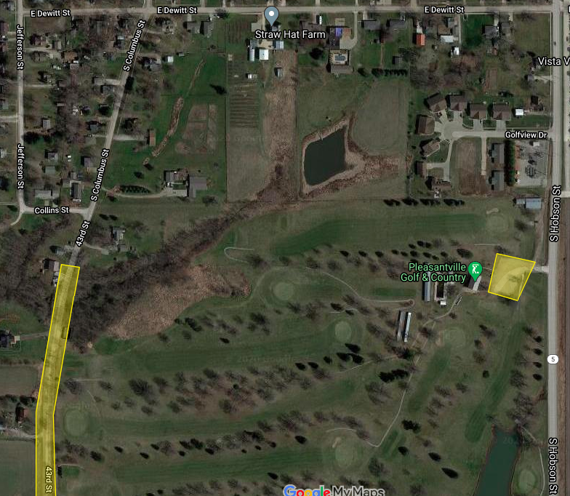
PARKING (yellow highlighted area) – Use parking lot, and street behind golf course.

